**APEX COLLEGE**

**POKHARA UNIVERSITY**

**LAB REPORT OF**

**DOT NEW TECHNOLOGY**

**LAB-1**

**Submitted By:                                               Submitted To:**

**Ruchi Agrawal                                               Bishwomitra Adhikari**

**BCIS ‘Adware’** **Ananta Pant**

**Roll no:18**

Objectives:

* TO GET FAMILIAR WITH MVC FRAMEWORK

1. Make a model named **Check.cs**

using System;

namespace lab1.Models

{

    public class Check

    {

        public int a {get;set;}

    }

}

2. In controller make an object to display odd or even number named **HomeController.cs**

using System;

using System.Collections.Generic;

using System.Diagnostics;

using System.Linq;

using System.Threading.Tasks;

using Microsoft.AspNetCore.Mvc;

using Microsoft.Extensions.Logging;

using lab1.Models;

namespace lab1.Controllers

{

    public class HomeController : Controller

    {

        private readonly ILogger<HomeController> _logger;

        public HomeController(ILogger<HomeController> logger)

        {

            _logger = logger;

        }

        public IActionResult Index()

        {

             var model =  new Person();

          model.name="Ruchi Agrawal";

          model.address="ason,newroad";

          return View(model);

        }

        [HttpPost]

        public IActionResult Check(int a)

        {

            var r ="even";

            if(a%2==0)

                r="even";

            else

                r="odd";

                ViewBag.Result=r;

                return View();

        }

        [HttpGet]

        public IActionResult Check()

        {

            return View();

        }

        public IActionResult Privacy()

        {

            return View();

        }

        [ResponseCache(Duration = 0, Location = ResponseCacheLocation.None, NoStore = true)]

        public IActionResult Error()

        {

            return View(new ErrorViewModel { RequestId = Activity.Current?.Id ?? HttpContext.TraceIdentifier });

        }

    }

}

1. Showing the output in the view **Check.cshtml**

@model lab1.Models.Check

@{

    ViewData["Title"]="Check Page";

}

@using (Html.BeginForm())

{

    <input type="text" name="a">

    <input type="submit" name="submit" value="Check Even or Odd" class="btn btn-info">

}

@{

    var result=ViewBag.Result;

    <p>@result</p>

}

**Output**

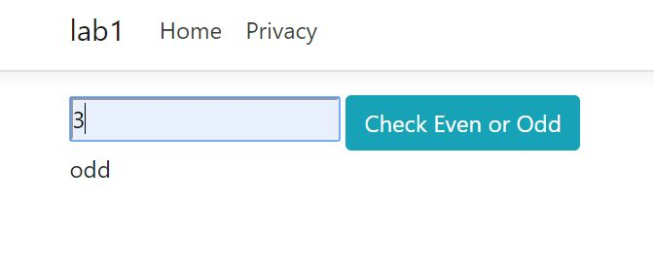

**CONCLUSION**

In lab 2, we learned to use basics of MVC framework to find the odd or even number.